**ASSIGNMENT 2 - DATA ANALYTICS WITH TABLEAU**

**1.Donut Chart**

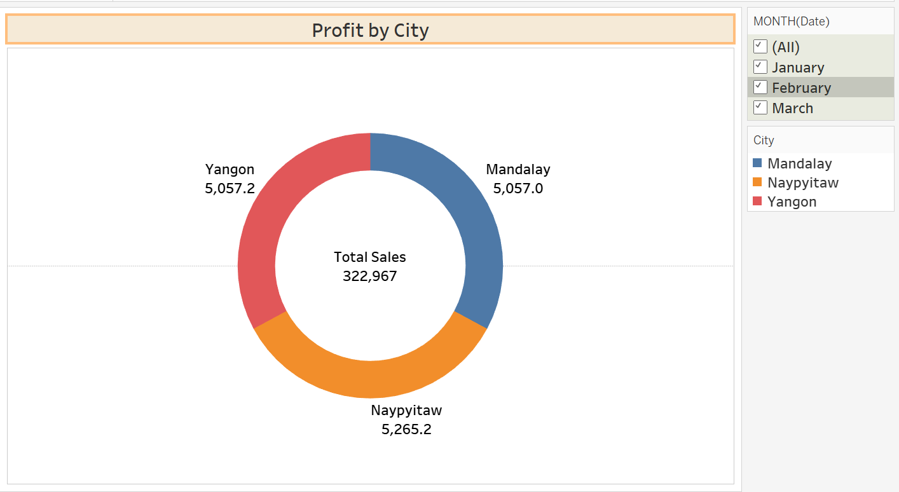

**2.Area Chart**

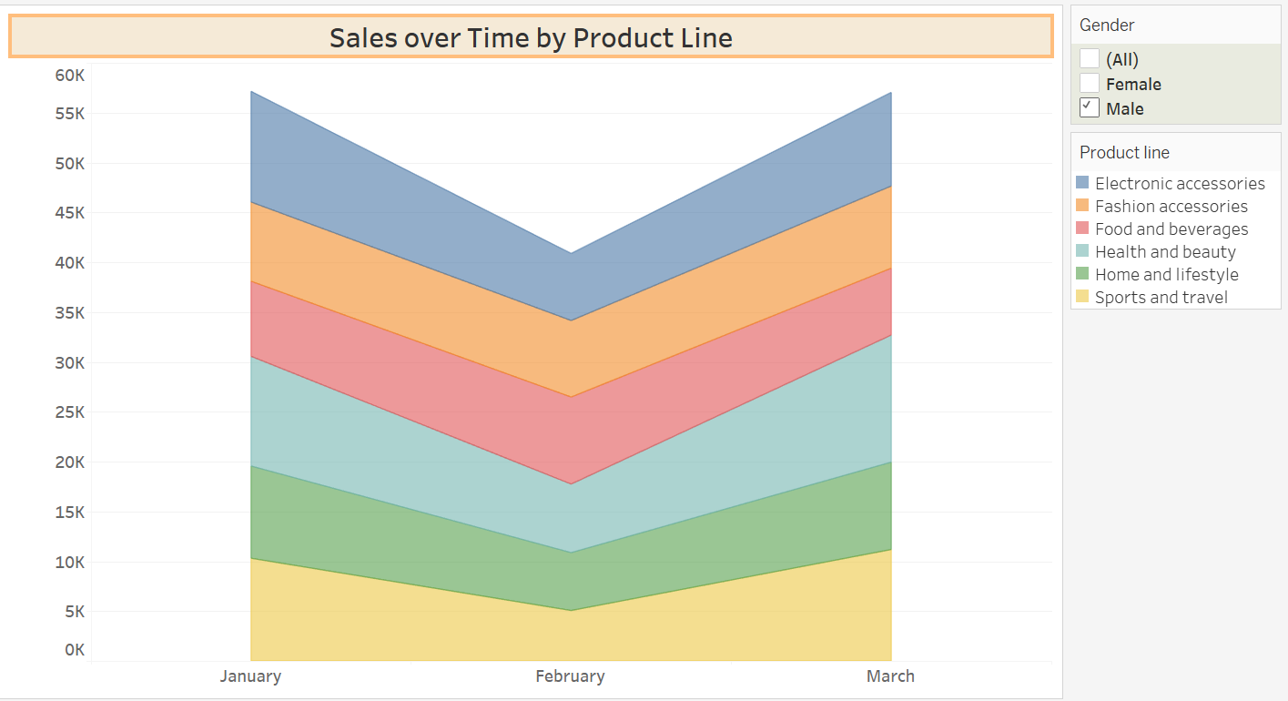

**3.Text Table**

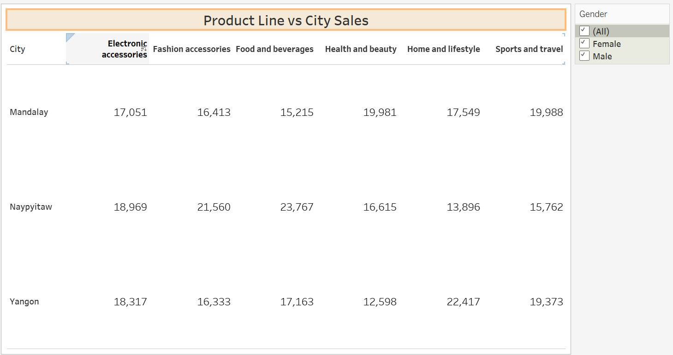

**4.Highlighted Table**

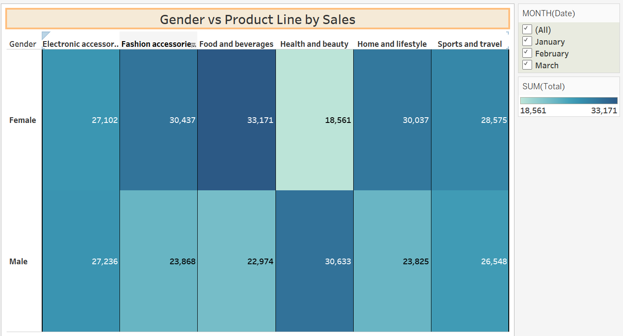

**5.Word Cloud**

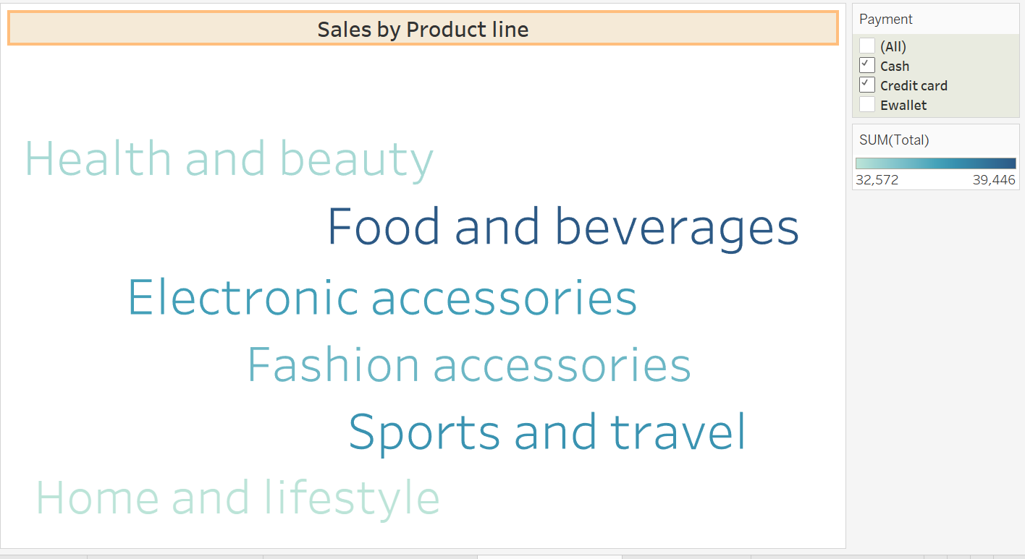

**6.Funnel Chart**

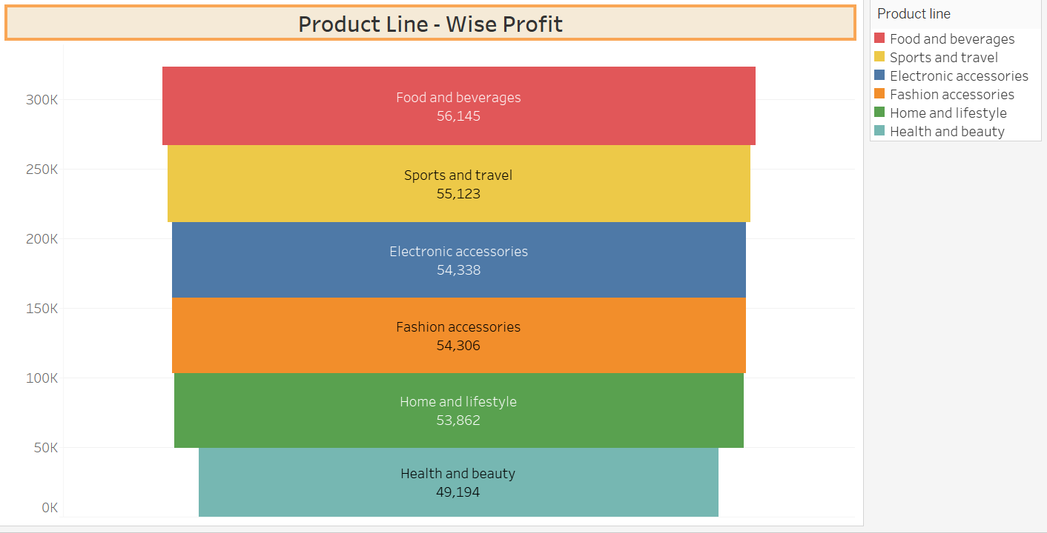

**7.Waterfall Chart**

